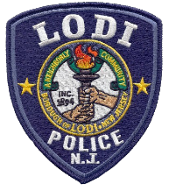
LODI POLICE DEPARTMENT
COMMUNITY POLICING UNIT
Lieutenant Anthony Mobilio
One Memorial Drive
Louis Franco, Jr.
Deputy Chief of Police
Lodi, New Jersey 07644
Donald Scorzetti Chief of Police
Tel: 973-473-7600 Ext. 8126
amobilio@lodipd.org

THE LODI POLICE DEPARTMENT COMMUNITY POLICING UNIT
IN CONJUCTION WITH THE
BOROUGH OF LODI MAYOR AND COUNCIL
AND WITH THE ASSISTANCE
OF THE
DEPARTMENT OF PUBLIC WORKS
ARE PLEASED TO ANNOUNCE OUR
“MILITARY MEMORIAL”

As an addition to the existing Walkway of Peace,
the Borough of Lodi will be honoring our deceased Lodi veterans
with a commemorative sign in honor of their
brave sacrifices to our country.
Family members of deceased veterans who were born or lived in Lodi
at the time of service in active war, are eligible to apply.

Kindly complete the
MILITARY MEMORIAL APPLICATION FORM
and submit to the Community Policing Unit as soon as possible.
This is our way of acknowledging the service of the men and women
from Lodi who defended our country.

