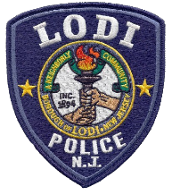
LODI POLICE DEPARTMENT
COMMUNITY POLICING UNIT
Lieutenant Anthony Mobilio
One Memorial Drive
Lodi, New Jersey 07644
Louis Franco, Jr.
Deputy Chief of Police
Donald Scorzetti Chief of Police
Tel: 973-473-7600 Ext. 8126
amobilio@lodipd.org
MILITARY MEMORIAL APPLICATION

NAME OF DECEASED VETERAN: ________________________________

BRANCH OF SERVICE: ________________________________

DATES OF SERVICE: ________________________________

CONFLICT SERVED IN: ________________________________

MILITARY AWARDS RECEIVED: ________________________________

SPONSORED BY: ________________________________

ADDRESS AND TELEPHONE NUMBER OF SPONSOR:

____________________________________________________________

- Applicants are encouraged to submit a photograph of the Veteran with this application for inclusion on the sign.

- Please be advised for authentication purposes, you must submit a copy of the Veteran’s DD214 in order to be eligible.

- For more information please contact Lieutenant Anthony Mobilio at
(973) 473-7600, Ext. 8126

Please note that there is no fee associated with this program.

